[Table_Main]
Research Report
5 Jan2026
Vistra Corp(VST US)
Active Response to Energy Transition and Enhancement of Low-Carbon Power Amid AI Data Center Migration and Natural Gas Demand Growth: Initiation
 |  | Vistra: Strategic Expansion Amid Energy Transition. Vistra, a leading Fortune 500 integrated retail electricity and power generation company based in Irving, Texas, plays a pivotal role in the U.S. energy market. The company's strategic acquisitions, including Dynegy Inc., Crius Energy, and Ambit Energy, have expanded its retail footprint and diversified its generation portfolio, which includes natural gas, nuclear, coal, solar, and battery energy storage. Vistra operates in all major competitive wholesale markets and serves approximately 5 million customers through its retail brands. Vistra's strategic acquisitions and organic growth projects have significantly expanded its generation capacity, particularly in natural gas, which has been a key area of focus. The company's recent acquisition of seven natural gas plants from Lotus Infrastructure Partners in October 2025 added approximately 2,600 MW. Vistra operates a significant nuclear fleet, contributing substantially to its zero-carbon generation portfolio. With over 6,448 MW of nuclear capacity across six reactors, including plants like Comanche Peak and the recently extended Perry plant.  Amidst the wave of AI, there is potential to benefit from the migration of domestic data centers. The U.S. power sector is undergoing significant transformation, with the migration of AI data centers and adjustments in the energy structure being central trends. As data centers migrate towards regions with lower electricity costs and more stable supply, the various U.S. ISO markets exhibit distinct energy mixes, typically led by natural gas, nuclear, and renewable energies (including wind, solar, and hydro), as coal's role diminishes. This shift indicates that electricity supply has become a key limiting factor in the development of digital infrastructure, particularly in established markets like Silicon Valley. Developers are now focusing on regions with abundant renewable energy resources, streamlined regulatory environments, and existing transmission infrastructure capable of supporting multi-gigawatt-scale developments to meet the power needs of AI data centers. This migration trend suggests that data centers will opt for regions with lower electricity costs, stable supply, and suitable climates for construction, which could positively impact companies like Vistra that have generation assets in these areas.  Natural gas power generation continues to grow to meet electricity demand. The United States has been witnessing a significant shift in its energy landscape, marked by a substantial increase in natural gas generation to meet escalating electricity demand. This surge is particularly notable as it is driven not just by the need to replace coal, but also by the growing demand from data centers and other large consumers. The U.S. Energy Information Administration reports that electricity demand in key regions managed by PJM and ERCOT is expected to grow significantly. This growth is fueled by the expansion of natural gas generation, which is expected to rise from 103.2 billion cubic feet per day in 2024 to 107.1 bcfd in 2025 and 107.4 bcfd in 2026, indicating a continued reliance on natural gas as a flexible and reliable power source. This trend is set to benefit companies like Vistra, which are actively expanding their natural gas generation capabilities, thereby positioning themselves to capitalize on the growing demand and support the transition towards a more sustainable energy future.  Valuation& recommendation  We estimate that revenue of Vistra Corp. from year 2025 to 2027 will be USD19,344 / 20,471 / 21,863 million, with the net profit of USD2,915 / 3,094 / 3,312 million. Based on the DCF valuation model, our target price is USD186.18, we initiate coverage on the stock with “Outperform”.  Risks  Electricity demand is lower than expected; Natural gas rise beyond expectation; Changes in regulatory policies.
  [Table_Info]
  Initiation with OUTPERFORM
  Rating | OUTPERFORM
  Current Price | 356.36
  Target Price | 423.72
  Market cap | 17.842bn
  Shares in issue | 45.69mn
  1 yr high - low | 451.28-158.08
  Note: Current Price 356.36 is the close price on 12 Dec 2025
  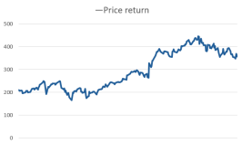
  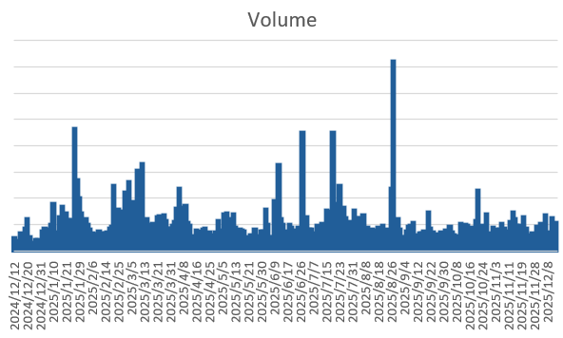
  Source: Company data, HFI
  [Table_Profit]
   | Dec-24A |  | Dec-25E |  | Dec-26E |  | Dec-27E
  Revenue | 2,115 |  | 2,300 |  | 2,620 |  | 2,714
  (+/-) | -17% |  | 9% |  | 14% |  | 4%
  Net Profit | 1,013 |  | 404 |  | 628 |  | 682
  (+/-) | 67% |  | -60% |  | 55% |  | 9%
  EPS | 17.67 |  | 6.89 |  | 10.85 |  | 11.81
  GPM | 53.1% |  | 56.1% |  | 60.8% |  | 61.6%
  ROE | 51.9% |  | 24.6% |  | 29.4% |  | 24.5%
  P/E | 20 |  | 52 |  | 33 |  | 30
  Source: Company data, HFI
[Table_Author]
Bin Yang
harryyang@hfisec.com.hk

Contents
1. Vistra: Major Fortune 500 player in the U.S. energy market 3
1.1 Company Overview 3
1.2 Adding nuclear and gas 5
1.3 Business performance 9
2 U.S. ISOs Landscape and AI Data Center Migration Trends 14
2.1 U.S. ISOs Analysis 14
2.2 ISOs regions - AI data center Migration 17
3 U.S. Energy Structure Adjustment and Natural Gas Demand Trends 20
4. Valuation& recommendation 23
5. Risks 25

1. Vistra: Major Fortune 500 player in the U.S. energy market

1.1 Company Overview
Vistra (NYSE: VST) is a leading Fortune 500 integrated retail electricity and power generation company based in Irving, Texas, that provides essential power resources to customers, businesses, and communities from California to Maine.

Vistra's storied history originates in 1882 with the establishment of the Dallas Electric Lighting Company. Since then, the company has undergone several pivotal transformations. In 2018, Vistra completed its merger with Dynegy Inc., creating the lowest-cost integrated power company in the industry. In 2019, Vistra acquired Crius Energy and Ambit Energy, expanding its retail footprint. In 2024, Vistra completed its integration with Energy Harbor Corp., creating a leading integrated retail electricity and zero-carbon generation company. In 2025, Vistra completed acquisition of seven natural gas plants, geographically expands its diverse generation portfolio, adding highly efficient assets across key competitive markets, including PJM, New England, New York, and California.
Figure: Vistra’s timeline
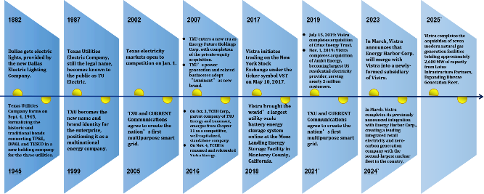

Source：Company Announcements , HFI
Ownership Structure: predominantly institutionally held. Like most utility companies in the United States, Vistra has no controlling shareholder. As of September 30, 2025, Vanguard Group Inc. is the largest shareholder with a 12.16% stake, while the top five shareholders—Vanguard Group Inc., Blackrock Inc., JPMORGAN CHASE & CO, FMR, LLC and State Street Corporation—collectively hold approximately 37.9%.

Figure: Vistra’s top Institutional holders
Shareholders | Shares | %Out
Vanguard Group Inc | 41.2M | 12.16%
Blackrock Inc. | 29.44M | 8.69%
JPMORGAN CHASE & CO | 21.87M | 6.45%
FMR, LLC | 19.89M | 5.87%
State Street Corporation | 16.04M | 4.73%
Total |  | 37.90%

Source: Finance Yahoo, HFI

Vistra is one of the largest competitive power generators in the U.S. It operates in all major competitive wholesale markets and Its portfolio includes natural gas, nuclear, coal, solar, and battery energy storage. Vistra is also a leading competitive electricity provider, offering over 50 renewable energy plans through its retail brands to approximately 5 million customers.

Vistra employs a fully integrated asset–customer configuration, coupling sizable centralized generation capacity with a material retail load book. The integrated exposure delivers an intrinsic natural hedge: in low-price environments the retail segment—obligated to purchase wholesale power to serve its customer load—captures expanded gross margin, whereas elevated market prices transfer value to the upstream generation portfolio, maximizing gross profit for the fleet.

Vistra Vision and Vistra Tradition are two distinct business segments of Vistra Corp., an integrated energy company, created as part of a strategic restructuring following the acquisition of Energy Harbor in March 2024. This segmentation allows Vistra to separate its growth-oriented, zero-carbon assets from its legacy, conventional generation.

Figure: Vistra is organized into two primary strategic buckets
Features | Vistra Vision | Vistra Tradition
Asset Type | Zero-carbon generation (nuclear, solar, battery storage) and retail | Conventional generation (natural gas and coal-fired plants)
Details | Nuclear fleet: The segment includes four nuclear plants (Comanche Peak, Davis-Besse, Perry, and Beaver Valley) with approximately 6.4 GW of zero-carbon capacity, making Vistra the second-largest competitive nuclear generator in the U.S..  Renewables and Storage (Vistra Zero): It encompasses Vistra's solar and battery energy storage projects, including the world's largest battery storage facility at Moss Landing, California.  Retail business: Vistra Vision manages the customer-facing retail operations, which serve millions of customers across various states under brands like TXU Energy and Dynegy. | While these are considered "transition" assets, their role is crucial in the current energy landscape because they provide "dispatchable" power (electricity that can be turned on or off quickly as needed) to ensure grid stability and reliability, especially during peak demand periods. 8
Strategic Role | Growth engine, focused on clean energy transition and sustainability | Provider of reliable, dispatchable power for grid stability
Ownership (as of late 2024) | Wholly owned subsidiary of Vistra Corp. | Wholly owned segment of Vistra Corp.

Source: Company Announcements, HFI

Vistra has major subsidiaries like TXU Energy, Luminant, and Dynegy, handling retail and generation, plus others like Homefield Energy, Ambit Energy, Crius Energy, and Energy Harbor for diverse energy services, with numerous specific power plants (like Coleto Creek) and holding companies (like Vistra Asset Co.) under them, all part of their integrated power and retail business.

Figure: Vistra's key brands and operations
Major Subsidiaries | Operations
 | TXU Energy is Texas’ No.1 choice in competitive electricity providers, powering the lives of more Texans than any other retailer.
 | Dynegy delivers simple, price-protected retail electricity plans throughout the Northeast, Mid-Atlantic, and Midwest.
 | Homefield Energy, a retail electricity supplier, proudly powers Illinois.
 | Energy Harbor is powering the clean energy future with safe, clean, reliable power — and a plan that’s right for you.
 | Ambit is the largest energy-focused direct seller in America, with an impressive network of independent consultants.
 | U.S. Gas & Electric is a leading provider of energy supply to commercial and residential customers across the Northeast, Mid-Atlantic, and Midwest.

Source: Company Announcements, HFI

1.2 Adding nuclear and gas

Vistra divides its business into six segments: Retail, Texas, East, West, Asset Closure and eliminations/ corporate and other. Retail engages in the sale of electricity and natural gas to residential, commercial, and industrial customers across 18 U.S. states and Washington D.C. under brands like TXU Energy, Ambit Energy, and Dynegy Energy Services. Texas segment engaged in electricity generation, wholesale energy sales and purchases, and commodity risk management within the ERCOT market. East segment involved in similar activities as the Texas segment, but in the Northeast, Mid-Atlantic, and Midwest markets. West segment represents electricity generation operations in the CAISO market, including battery energy storage system (BESS) projects. In the fiscal year 2024, the Retail segment generated a total revenue of approximately $12.8 billion, which represented just under 52% of the company's gross revenue for that year.

Figure: Vistra business segments map
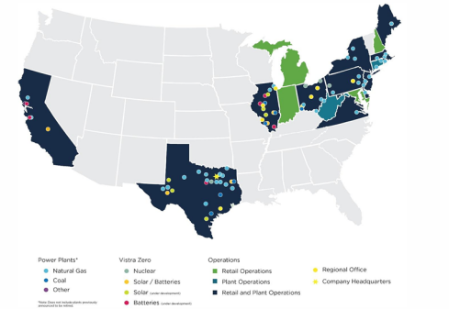
Source: Company Announcements, HFI
Note: As of Dec. 31, 2024. Shown pro-forma for the acquisition from Lotus.
- Based on 2024 actual production; Includes full year of Energy Harbor and excludes plants acquired from Lotus.

Vistra's fleet is diversified across multiple fuel sources. As of the end of 2024, its total capacity of 40,657 MW was composed of: Natural gas (59%), Coal (21%), Nuclear (16%) and Renewable sources (4%). Recently, Vistra did some strategic changes to their portfolio. Vistra completed the acquisition of seven modern natural gas facilities from Lotus Infrastructure Partners on October 22, 2025, adding approximately 2,600 MW across PJM, New England, New York, and California markets. As of October 31, 2025, Vistra's total generation capacity was approximately 43,257 MW. Also, Vistra has been working on various organic growth projects, including the completion of certain capacity upgrades and the expected commercial operation of the 200-MW Oak Hill solar project by the end of 2025.
Figure: Vistra’s generation by capacity and production（As of end of 2024）
Primary Fuel | Technology | Net Capacity (MW) | % of Net Capacity
Natural Gas | CCGT, CT or ST | 24,120 | 59%
Coal | ST | 8,428 | 21%
Uranium | Nuclear | 6,448 | 16%
Renewable | Solar/Battery | 1,474 | 4%
Fuel Oil | CT | 187 | <1%
Total |  | 40,657 | 100%

Source: Company Announcements, HFI

Figure: Vistra’s generation by capacity and production（As of October 31, 2025）
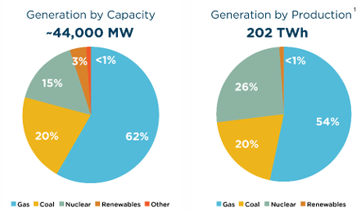
Source: Company Announcements, HFI

Vistra's generating capacity is indeed concentrated in Texas and the Eastern U.S., with approximately 96% of its 43.7 GW total capacity in those regions as of late 2025 data. Only a small fraction is in the West (California). Those numbers are set to grow through possible uprates at nuclear power plants and by building new resources. Vistra is currently adding new capacity, primarily in Texas, with plans to build an additional 860 MW of gas-fired generation in West Texas by mid-2028. Also, Vistra plans to finish analyzing nuclear capacity expansion by late 2025, potentially adding 10% (around 660 MW) to its 6.6 GW fleet for early 2030s operation, driven by data center demand, alongside major gas plant projects and long-term nuclear power purchase agreements (PPAs). This move supports clean energy goals, leverages existing nuclear assets like Comanche Peak and Beaver Valley, and solidifies Vistra's role in providing reliable, carbon-free power for growing energy needs.

Figure: Vistra’s generation operations by segment （As of October 31, 2025）
Segment | Net Capacity (MW) | % of Net Capacity | ISO/RTO
Texas | 19,858 | 45% | ERCOT
East | 22,254 | 51% | PJM, ISO-NE, MISO, and NYISO
West | 1,629 | 4% | CAISO
Total | 43,741 | 100%

Source: Company Announcements, HFI

Vistra operates a significant nuclear fleet, making it a major player in reliable, carbon-free baseload power, with over 6,448 MW of nuclear capacity across six reactors, including plants like Comanche Peak and the recently extended Perry plant, contributing substantially to their total generation portfolio, with plans to add even more nuclear capacity to meet growing U.S. electricity demand from AI and data centers.

.
Figure: Vistra own and operate six nuclear generation units at four different facilities （As of end of 2024）
Unit | Location | ISO | Net Capacity (MW) | In-Service Year | License Expiration Date
Comanche Peak Unit 1 | Glen Rose, TX | ERCOT | 1200 | 1990 | 2050
Comanche Peak Unit 2 | Glen Rose, TX | ERCOT | 1200 | 1993 | 2053
Beaver Valley Unit 1 | Shippingport, PA | PJM | 939 | 1976 | 2036
Beaver Valley Unit 2 | Shippingport, PA | PJM | 933 | 1987 | 2047
Perry | Perry, OH | PJM | 1268 | 1986 | 2026
Davis-Besse | Oak Harbor, OH | PJM | 908 | 1978 | 2037
Total |  |  | 6448

Source：Company Announcements , HFI

Vistra Receives Approval to Extend Operation of Perry Nuclear Plant Through 2046. On July 7, 2025, Vistra announced that it has received approval from the Nuclear Regulatory Commission to extend the operation of its 1,268-megawatt Perry Nuclear Power Plant through 2046, an additional 20 years beyond its original license. The plant first connected to the grid in 1986 and is currently operating under its initial 40-year license. The company submitted its application for license renewal to the NRC in 2023. Extending operations at Perry ensures that Ohio continues to benefit from a resilient source of baseload power, supporting jobs, economic activity, and grid reliability across the region. With this latest approval, all six reactors in Vistra's fleet have received license extensions.

Figure: Comanche Peak Nuclear Power Plant
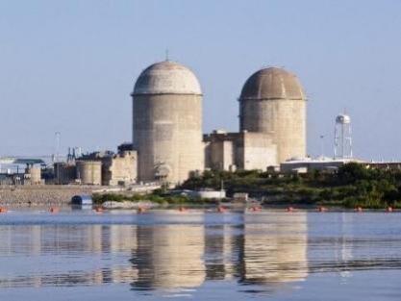
Source: Company Announcements, HFI

In late September 2025, Vistra announced a major strategic move in Texas, securing a 20-year deal for 1,200 MW of carbon-free power from its Comanche Peak Nuclear Plant and simultaneously greenlighting capacity expansion with two new gas units at its Permian Basin plant, aiming to meet rising power demands with a mix of nuclear and dispatchable gas power, enhancing grid reliability and boosting Vistra's financial stability through long-term contracts.

1.3 Business performance
Vistra's third-quarter performance saw solid growth. For the quarter ended September 30, 2025, Vistra reported Net Income of $652 million and Ongoing Operations Adjusted EBITDA1 of $1,581 million. Net Income for the third quarter 2025 decreased $(1,185) million compared to the third quarter 2024, driven primarily by lower unrealized mark-to-market gains on derivative positions with a decrease of $(1,671) million, and impacts of the Martin Lake Unit 1 outage, partly offset by the recognition of nuclear production tax credit (PTC) revenue and higher capacity prices. Ongoing Operations Adjusted EBITDA for the third quarter 2025 increased by $143 million compared to the third quarter 2024, driven primarily by higher realized energy and capacity prices, and the recognition of nuclear PTC revenue, partly offset by the impacts of the Martin Lake Unit 1 outage.

Figure: Vistra’s 2025Q3 financial results
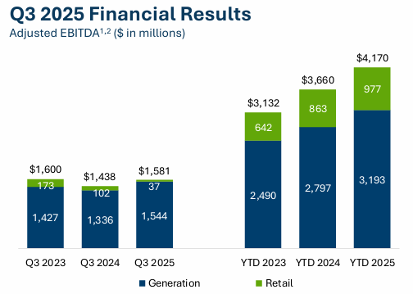
Source: Company Announcements, HTI

Vistra's total operating revenue for the 2025Q1-Q3 was $13.15 billion (-0.25% year-over-year), and the total operating revenue for the 2025Q3 was $4.97 billion (-21% year-over-year). The miss was driven partly by lower unrealized mark-to-market gains on derivatives and the impact of a Martin Lake Unit 1 outage, while realized energy and capacity prices improved.

Figure: Vistra's 2021-2025Q3 Revenue (USD mn) & YoY (%) |  | Figure: Vistra's 2021Q3-2025Q3 Revenue (USD mn) & YoY (%)
Source: Company Announcements, ifind,HFI |  | Source: Company Announcements, ifind,HFI

In 2024, the decline in natural gas prices played a role in enhancing the company's profitability. Specifically, in the Permian Basin region, prices dropped from $1.53/MMBtu to $0.08/MMBtu. Since natural gas is a primary fuel for the company's power generation business, the reduction in costs directly translates into higher profit margins, thereby strengthening the company's profitability. This cost advantage not only improves the company's financial performance but also enhances its competitiveness in the energy market, laying a solid foundation for future profit growth.

Figure: 2023&2024 average power price comparison |  | Figure: 2023&2024 average natural gas price comparison
  Average Power Price ($/MWh) | 2024 | 2023
  ERCOT North Hub | $25.89 | $48.30
  ERCOT West Hub | $27.45 | $49.45
  PJM AEP Dayton Hub | $30.74 | $30.81
  PJM Northern Illinois Hub | $25.46 | $26.64
  PJM Western Hub | $33.83 | $33.07
  MISO Indiana Hub | $31.36 | $32.98
  ISO-NE Massachusetts Hub | $41.47 | $36.82
  New York Zone A | $32.66 | $25.68
  CAISO NP15 | $40.67 | $61.37
  Average Natural Gas Price ($/MMBtu) | 2024 | 2023
  NYMEX Henry Hub | $2.25 | $2.53
  Houston Ship Channel | $1.87 | $2.20
  Permian Basin | $0.08 | $1.53
  Dominion South | $1.67 | $1.63
  Tetco ELA | $2.08 | $2.27
  Chicago Citygate | $2.12 | $2.30
  TetcoM3 | $2.07 | $1.90
  Algonquin Citygates | $3.03 | $2.94
  PG&E Citygate | $3.09 | $6.09
Source: Company Announcements, ifind, HFI |  | Source: Company Announcements, ifind, HFI

From 2021 to 2024, Vistra’s consolidated gross margin rose from 24.08% to 57.7%, driven by higher wholesale electricity prices and lower natural gas costs. In the first three quarters of 2025, the margin eased to 48.37%, still well above historical levels and indicating continued expansion in profit per MWh. By segment, Texas exceeded 70.41% in 2024 and remains above 60% in 2025 Q1-Q3, while the East segment, supported by rising capacity prices, has stabilized at 35–50%.

Figure: Vistra's 2021-2025Q1-Q3 Total Gross Margin |  | Figure: Vistra's 2021-2025Q1-Q3 Gross Margin of segments
Source: Company Announcements, ifind, HFI |  | Source: Company Announcements, ifind, HFI

According to EIA, after relatively little change in U.S. electricity demand between 2005 and 2020, retail sales of electricity have begun growing again, driven by rising demand in the commercial and industrial sectors. Developers have proposed numerous data centers and large manufacturing facilities that could consume significant amounts of electricity, and many of these projects are concentrated in the ERCOT and PJM regions. But, the timing of these facilities’ initial operations remains uncertain. They expect that electricity demand in PJM will grow by 3.3% in both 2025 and 2026, while demand in ERCOT grows by 5.0% in 2025 and 9.6% in 2026.
Figure: PJM & ERCOT forecast change in electricity sales to ultimate customers
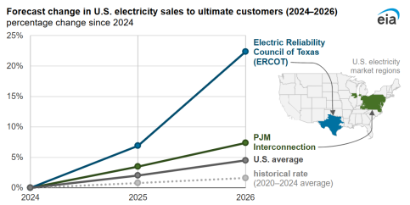
Source: eia, HTI

Over the past two decades, PJM’s capacity price remained depressed amid oversupply and declining load, with the 2022/23 Base Residual Auction (BRA) clearing at only about 50 USD/MW-day (PJM BRA Results, 2022). As load forecasts were revised upward, the 2024 BRA for the 2025/26 delivery year surged to 269 USD/MW-day, and the July 2025 BRA for 2026/27 further climbed to approximately 330 USD/MW-day (PJM BRA Results, 2024 & 2025)—more than five times the historical low. On Dec. 17, 2025, PJM Interconnection announced the results of its 2027/2028 Base Residual Auction (BRA), the price came in at the FERC-approved cap, $333.44/MW-day (UCAP) for the entire PJM footprint, a slight increase (+1.3%) from the 2026/2027 Base Residual Auction. Market participants widely expect that, against a backdrop of rapid demand growth and higher system reserve requirements, PJM capacity prices will stay persistently high—multiples above the long-term average—providing steady and substantial capacity revenues for units with flexible dispatch capabilities.

Figure: RPM Base Residual Auction Resource Clearing Price Results in the RTO
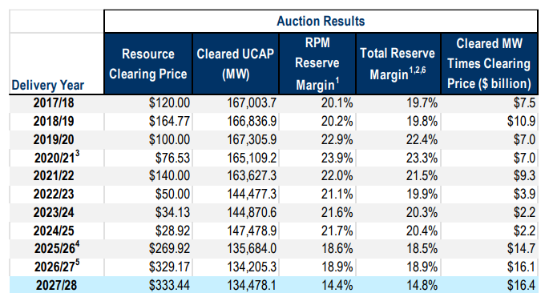
Source: PJM, HTI

Figure: PJM Capacity Prices ($/MW-day)
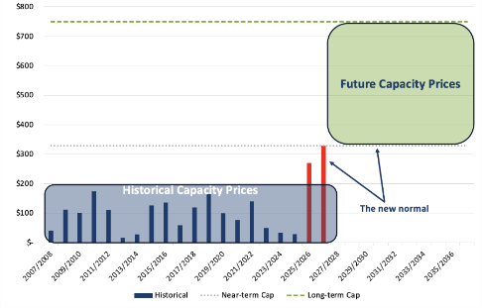
Source: Ascend Analytics, HTI

ERCOT electricity prices have seen periods of stability recently (2024-2025) compared to past volatility, driven by milder weather, increased renewables (solar/storage), and lower natural gas prices, leading to less extreme price spikes. In the short term, ElectricityPlans expect a modest 3-5% rise in electricity prices in Texas from 2025 to 2026. Residential electricity rates will be 14-19¢/kWh including delivery costs, and commercial electricity rates will average 7-9¢/kWh excluding delivery. Over the long term, ERCOT electricity prices are still expected to trend upward, but the overall trajectory is likely to remain more stable than in PJM. Between 2021 and 2024, ERCOT's electricity prices have experienced notable changes in both cost and volatility, especially in relation to natural gas price trends. As one of the most important fuel sources for electricity generation in Texas, natural gas prices have a direct impact on the market’s locational marginal prices (LMPs). Natural gas long-term prices peaked in the summer of 2022, after rising steadily from 2021, and have since stabilized at lower levels in 2023 and 2024.

Figure: 2021-2024 natural gas prices in ERCOT
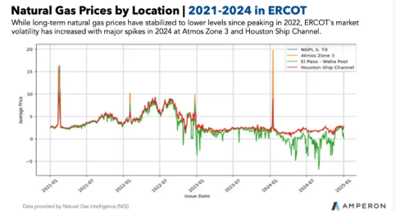
Source: Amperon, HTI

U.S. energy firms produced a record amount of natural gas during the third quarter as producers scrambled to keep up with soaring domestic and export demand for the fuel. Power-hungry data centers and a boom in liquefied natural gas (LNG) exports are driving up U.S. gas use, pushing producers to pull more gas out of the ground. Both supply and demand are set to hit record highs in 2025 and 2026, according to the U.S. Energy Information Administration. There's a strong trend of declining natural gas prices, especially when adjusted for inflation, driven by record U.S. production outstripping demand, though seasonal weather spikes and strong LNG exports can cause short-term volatility; forecasts predict continued moderation through 2026. Natural gas's role as the marginal fuel often dictates market prices in ERCOT and PJM, so its price has a strong influence. A decrease in natural gas prices generally lowers wholesale electricity prices in ERCOT and PJM because gas often sets the marginal cost, reducing operating expenses for generators, which should increase generator profits per MWh by lowering fuel costs.

Figure: 2022-2025 U.S. natural gas price
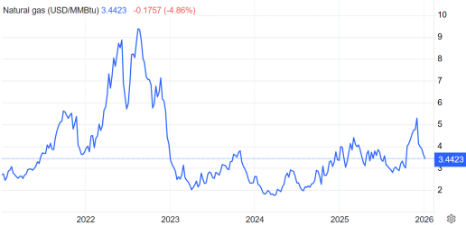
Source: Trading Economics, HTI

Figure: Natural gas prices forecast
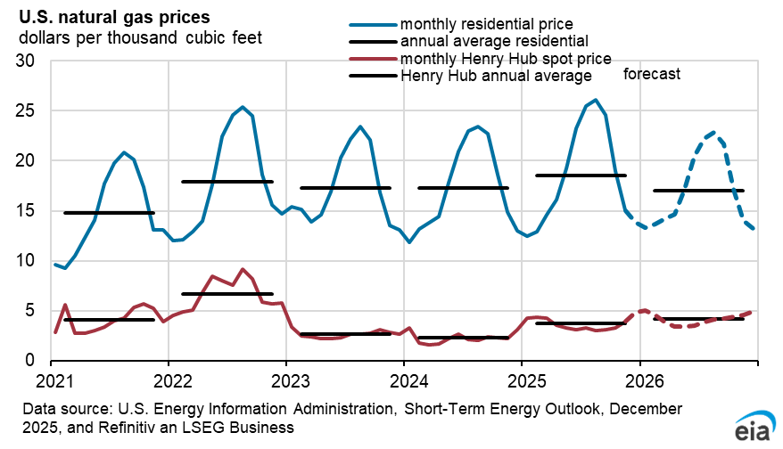
Source: eia, HTI

Vistra has refined its projected adjusted EBITDA for 2025 to a range of $5.7 billion to $5.9 billion for its continuing operations. What's more significant is the introduction of a forecast for 2026, set between $6.8 billion and $7.6 billion, which suggests an increase of 22% to 29% from the midpoint of the 2025 estimates. This indicates a substantial uptick in growth, and such a forecast would not be made by the management unless they were certain about the factors propelling this growth.

Figure: Narrowing 2025 and Affirming 2026 Guidance
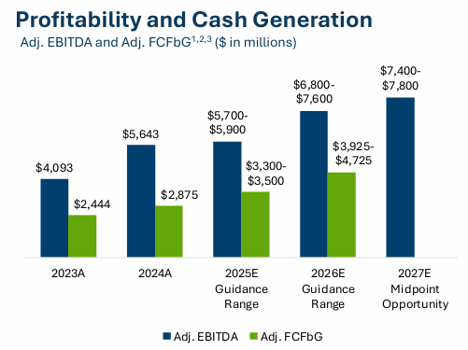
Source: Company Announcements, HTI

2 U.S. ISOs Landscape and AI Data Center Migration Trends

2.1 U.S. ISOs Analysis
The U.S. is split into 10 distinct transmission regions. The Southeast, Southwest, and Northwest all have traditional wholesale electricity markets where utilities are responsible for grid operations and management as well as providing electricity to customers. The remaining seven are ISOs or RTOs (see map). ISOs include the California ISO (CAISO), the Midcontinent Independent System Operator (MISO), the New York Independent System Operator (NYISO), and ISO New England (ISO-NE). The Electric Reliability Council of Texas (ERCOT) is also an ISO, though it does not fall under the purview of FERC. The Southwest Power Pool (SPP) and PJM have RTO status.

Figure: The U.S. is split into 10 distinct transmission regions
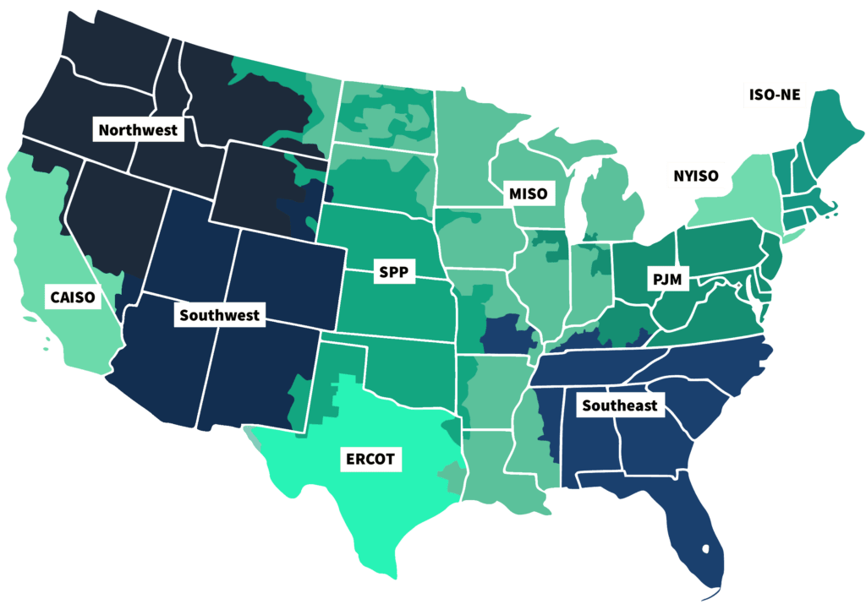
Source: PCI energy soulution, HFI

The energy mix across U.S. ISO regions shows notable differences, typically led by natural gas, nuclear, and renewable energies (including wind, solar, and hydro), as coal's role diminishes.

ERCOT (Electric Reliability Council of Texas): Natural gas is the main source, but the region also has a significant and growing share of wind and solar power. Coal generation has been declining.

CAISO (California ISO): The generation mix is diverse, with significant contributions from imports and renewable.

SPP (Southwest Power Pool): Renewables, particularly wind, have grown significantly in the SPP region, which experienced conditions where intermittent generation frequently sets the clearing price. Natural gas capacity has also increased.

PJM (Pennsylvania, New Jersey, Maryland, etc.): Natural gas is the current primary source, followed by coal and nuclear power. PJM's coal share has been declining but remains a notable part of the mix.

MISO (Midcontinent ISO): Historically reliant on coal, MISO has seen a decline in coal usage and an increase in natural gas and renewables. Natural gas generation has grown significantly in the region.

NYISO (New York ISO): New York's mix includes a variety of sources, with dual-fuel (natural gas and oil) and nuclear power being significant. Like ISO-NE and CAISO, the share of coal is very low.

ISO-NE (ISO New England): The region heavily relies on natural gas and nuclear power, with a substantial portion of imported electricity (mostly hydropower from Eastern Canada). Coal use is very low (less than 3%).

IESO (The Independent Electricity System Operator): electricity supply is primarily generated from nuclear power, followed by a mix of hydroelectric, natural gas, wind, and solar energy. The distribution of power types changes in real-time based on demand and availability.

Figure: U.S. ISO Power Market Analysis
ISO | Load (MW) | Net Load (MW) | Price ($/MWh) | Main Source
ERCOT | 444,600 | 29,614 | $15.32 | Natural Gas
CAISO | 19,120 | 16,057 | $15.73 | Imports
SPP | 28,229 | 13,439 | $19.23 | Wind
PJM | 97,760 | 90,445 | $27.92 | Gas
MISO | 67,483 | 55,439 | $23.55 | Coal
NYISO | 19,565 | 18,809 | $67.09 | Dual Fuel
ISO-NE | 15,736 | 14,524 | $65.68 | Natural Gas
IESO | 17,341 | 13,122 | $44.27 | Nuclear

Source: gridstatus.io, HFI

Figure: Recent energy type distribution in ISO regions
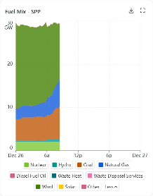
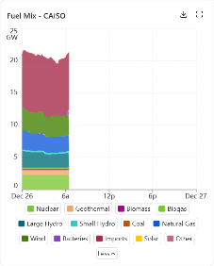
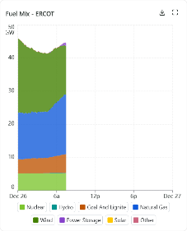
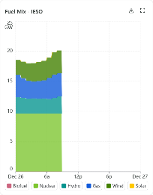
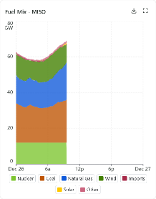
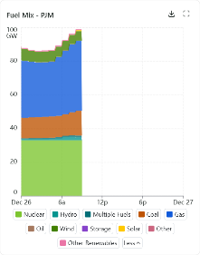

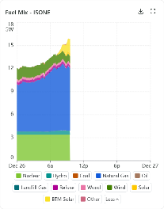
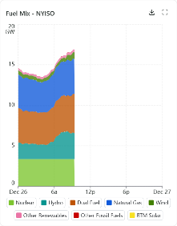

Source：gridstatus.io , HFI

2.2 ISOs regions - AI data center Migration
Data Center Map estimates that the U.S. has over 4,000 data centers, including operational sites and those under development. A third of U.S. data centers are in just three states: Virginia (643), Texas (395) and California (319). Some of the nation’s key data center hubs are in northern Virginia, Dallas, Chicago and Phoenix. It’s likely they’ll retain their leading status: Half of the data centers currently being built in the U.S. are part of preexisting large clusters, according to an April report from the International Energy Agency (IEA).

Figure: U.S Data Center Map
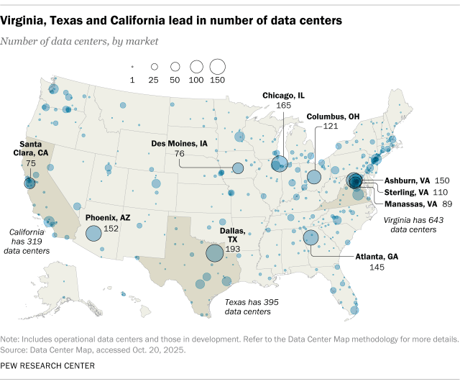
Source: Pew Research Center, HFI

In 2024, the total electricity consumption in the U.S. reached an all-time high, with potential for further increases as data centers continue to expand rapidly. According to the IEA, U.S. data centers consumed 183 terawatt-hours (TWh) of electricity, accounting for over 4% of the nation's total electricity usage and comparable to Pakistan's yearly demand. By 2030, this consumption is expected to surge by 133% to 426 TWh.

Data centers, due to their concentrated geographic distribution, exert substantial pressure on power grids. In 2023, they accounted for approximately 26% of Virginia's total electricity usage and notable portions in North Dakota (15%), Nebraska (12%), Iowa (11%), and Oregon (11%), as reported by the Electric Power Research Institute.

Figure: Energy do U.S Data Center use predict
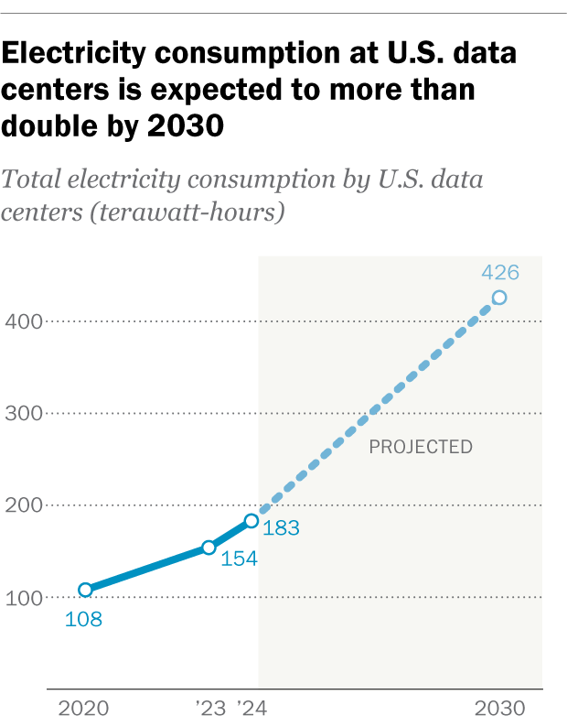
Source: Pew Research Center, HFI

AI data centers are migrating and expanding into regions managed by Independent System Operators (ISOs), such as PJM and CAISO in the United States, primarily driven by the critical need for abundant, reliable, and affordable power. The increasing demand for computational power from generative AI workloads is prompting a significant shift in data center location strategies. The migration to certain ISO regions is primarily driven by three factors: power availability and cost, grid interconnection and reliability, and physical space and infrastructure. AI data centers demand substantial power, often on a gigawatt scale, making regions with reliable power supply and competitive pricing highly desirable. Consequently, we anticipate that the trend of data center migration will lead to the selection of regions with lower electricity costs, stable supply, and suitable climate for their construction.

According to Cushman & Wakefield’s analysis, Virginia is significantly ahead in terms of current operations, construction, and future planning of data centers across six major U.S. markets, highlighting its leading position in the industry. Dallas, Phoenix, and Chicago also demonstrate considerable potential for growth, particularly in planned capacity, while Portland shows a steady but modest increase. Silicon Valley has the smallest overall presence, indicating slower growth compared to other top markets.

This shift indicates that electricity has become a key limiting factor in the development of digital infrastructure, particularly in established markets such as Silicon Valley. Developers are now focusing on regions that have abundant renewable energy resources, streamlined regulatory environments, and existing transmission infrastructure capable of supporting multi-gigawatt-scale developments to meet the power needs of AI data centers.

Figure: Data Center Capacity by Primary U.S. Markets: In Operation, Under Construction, and Planning（2024, MW）
State | Top Markets | In Operation | Under Construction | Planning
Virginia | Virginia | 5,926 | 1,834 | 15,432
Oregon | Portland | 1,970 | 236 | 937
Arizona | Phoenix | 1,541 | 478 | 1,541
Texas | Dallas | 1,368 | 500 | 4,046
Illinois | Chicago | 1,159 | 169 | 2,557
California | Silicon Valley | 967 | 39 | 1,061

Source: Cushman & Wakefield, America’s Data Center H2 2024 Update, Cushman & Wakefield, Americas Data Center Markets Map, americanactionforum, HFI

Vistra owns power generation assets across ISOs markets, particularly in regions with high electricity demand, such as Texas, providing stable and reliable power supply for AI data centers. Given Vistra's strong market position in these areas, this represents a significant advantage for AI data centers seeking to reduce operational costs. As data centers migrate towards regions with lower electricity costs and stable supply, Vistra is expected to leverage its generation capabilities in these regions to support the expansion and growth of data centers.

3 U.S. Energy Structure Adjustment and Natural Gas Demand Trends
For almost two decades, emissions from the U.S. power sector have been on a downward trend, averaging a 2.3% annual decrease since the peak of coal-fired generation in 2007, leading to a cumulative 333% reduction by 2024. The surge of wind and solar energy, coupled with the transition from coal to natural gas, has been pivotal, cutting coal's proportion in the power mix from 49% in 2007 to an all-time low of 15% in 2024. Concurrently, established clean technologies such as hydro and nuclear power have sustained their presence in the energy mix. Despite growing demand, the U.S. grid has continued to improve in cleanliness. The expansion of wind, solar, and natural gas has helped to stabilize emissions amidst increasing consumption.
Figure: Evolution of U.S. Energy Structure from 2000 to 2024
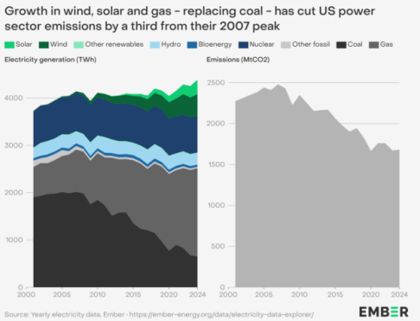
Source：EMBER, HFI

In 2024, the expansion of natural gas generation played a pivotal role in addressing the escalating electricity demand, rather than merely supplanting coal. The U.S. witnessed a substantial rise in gas-fired power generation, increasing by 3.3%, which translates to an additional 59 TWh. This growth is on par with the average annual expansion observed over the past decade, amounting to an increase of 68 TWh. A distinguishing feature of 2024 was the primary contribution of the increase in natural gas, along with solar and wind, to meet the surge in electricity demand, as opposed to replacing coal. The overall electricity demand climbed by 128 TWh, while coal generation dipped by 22 TWh, with natural gas, solar, and wind collectively accounting for the 150 TWh shortfall.

Figure: U.S. natural gas and clean energy generation and demand are rising
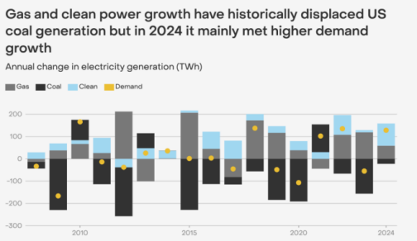
Source：EMBER, HFI

The expansion of natural gas generation may benefit Vistra by increasing its reliable, flexible power supply, meeting surging demand (especially from data centers), enhancing grid stability, boosting revenues from capacity markets, and supporting economic growth in key regions like Texas and the Northeast. Vistra actively acquires and builds natural gas plants, seeing it as crucial for reliable, affordable energy, despite their other clean energy initiatives, leveraging gas as a bridge fuel and for firm capacity. Natural gas provides Vistra with the flexible, firm power needed to support a changing energy landscape, complementing their existing and future renewable assets.

U.S. energy companies set a new production record for natural gas in 2025 Q3, driven by high domestic and export demands. The rise in usage is fueled by data centers' energy consumption and increased LNG exports. The EIA anticipates production to rise from 103.2 billion cubic feet per day (bcfd) in 2024 to 107.1 bcfd in 2025 and 107.4 bcfd in 2026, surpassing the previous record of 103.6 bcfd in 2023. Gas consumption, including exports, is forecast to increase from a record 111.5 bcfd in 2024 to 115.7 bcfd in 2025 and 117.7 bcfd in 2026. Major U.S. energy firms, such as Expand Energy and EQT, produce nearly 25% of the nation’s gas, primarily from shale formations like the Marcellus and Utica in Pennsylvania, Ohio, and West Virginia, and the Haynesville in Louisiana and Texas.

According to the U.S. Energy Information Administration, the increase in power generation in 2025 is largely driven by the rising demand for electricity from data centers and other major customers in Texas, where the grid is managed by the Electric Reliability Council of Texas (ERCOT); and in the Mid-Atlantic/Ohio Valley region, the grid is managed by the PJM Interconnection (PJM). They anticipate that electricity demand in PJM will grow by 3.3% in both 2025 and 2026, while demand in ERCOT will increase by 5.0% in 2025 and by 9.6% in 2026.

Figure: Electric power sector net generation by source
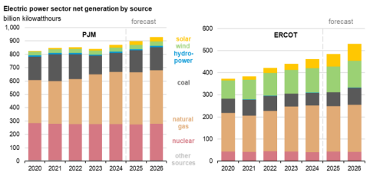
Source: U.S. Energy Information Administration, HFI

4. Valuation& recommendation
We estimate that revenue of Vistra Corp. from year 2025 to 2027 will be USD19,344 / 20,471 / 21,863 million, with the net profit of USD2,915 / 3,094 / 3,312 million. Based on the DCF valuation model, our target price of Talen is USD186.18, we initiate coverage on the stock with “Outperform”.

Table: DCF Model
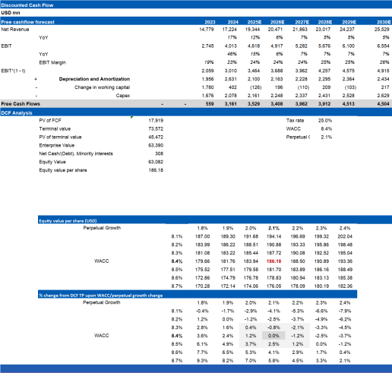

Source: Company Announcements, HTI

Table: Financial Summary
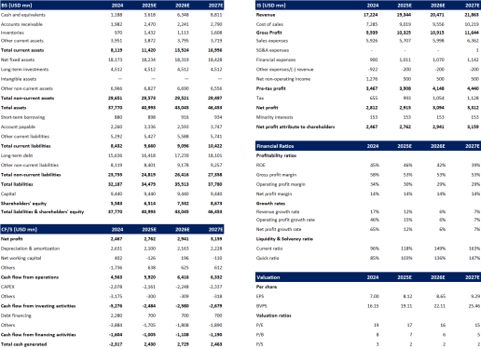
Source: Company Announcements, HTI

5. Risks

Electricity demand is lower than expected; Natural gas rise beyond expectation; Changes in regulatory policies.
[Table_disclaimer]
APPENDIX
IMPORTANT DISCLOSURES
This research report is distributed by HuaFu International (HK) Financial Holdings Limited (referred as HuaFu International below), which is authorized to engage in securities activities in its respective jurisdiction.
Analyst Certification:
I, Bin Yang, certify that (i) the views expressed in this research report accurately reflect my personal views about any or all of the subject companies or issuers referred to in this research and (ii) no part of my compensation was, is or will be directly or indirectly related to the specific recommendations or views expressed in this research report; and that I (including members of my household) have no financial interest in the security or securities of the subject companies discussed.
Conflict of Interest Disclosures
HuaFu International and some of its affiliates may engage in investment banking and / or serve as a market maker or hold proprietary trading positions of certain stocks or companies in this research report. As far as this research report is concerned, please send an email to lcd@hfisec.com.hk if the information about any company mentioned in this report is needed).
Ratings Definitions (from 1 Jul 2020):
HuaFu International uses a relative rating system using Outperform, Neutral, or Underperform for recommending the stocks we cover to investors. Investors should carefully read the definitions of all ratings used in HuaFu International Research. In addition, since HuaFu International Research contains more complete information concerning the analyst's views, investors should carefully read HuaFu International Research, in its entirety, and not infer the contents from the rating alone. In any case, ratings (or research) should not be used or relied upon as investment advice. An investor's decision to buy or sell a stock should depend on individual circumstances (such as the investor's existing holdings) and other considerations.
Analyst Stock Ratings
Outperform: The stock’s total return over the next 12-18 months is expected to exceed the return of its relevant broad market benchmark by over 10%, as indicated below.
Neutral: The stock’s total return over the next 12-18 months is expected to be in line with the return of its relevant broad market benchmark, as indicated below. Underperform: The stock’s total return over the next 12-18 months is expected to be below the return of its relevant broad market benchmark by over 10%, as indicated below.
Benchmarks for each stock’s listed region are as follows: Japan – TOPIX, Korea – KOSPI, Taiwan – TAIEX, India – Nifty100, US – SP500; for all other China-concept stocks – MSCI China.

HuaFu International Non-Rated Research: HuaFu International publishes quantitative, screening or short reports which may rank stocks according to valuation and other metrics or may suggest prices based on possible valuation multiples. Such rankings or suggested prices do not purport to be stock ratings or target prices or fundamental values and are for information only.
HuaFu International Coverage of A-Shares: HuaFu International may cover and rate A-Shares . HuaFu Securities, the ultimate parent company of HuaFu International based in FuZhou, covers and publishes research on these same A-Shares for distribution in mainland China. However, the rating system employed by HuaFu International differs from that used by HuaFu Securites and even the teams covering the same A-share stocks might be totally independently different, as a result there may be a difference in their coverage ratings, target prices and research logics for the same A-share stocks.
IMPORTANT DISCLAIMER
The research report is issued by HuaFu International, a licensed corporation to carry on Type 4 regulated activity (advising on securities) for the purpose of the Securities and Futures Ordinance (Cap. 571) of Hong Kong.
The information and opinions contained in this research report have been compiled or arrived at from sources believed to be reliable and in good faith but no representation or warranty, express or implied, is made by HuaFu International or any other related members from which this research report may be received, as to their accuracy, completeness or correctness. All opinions expressed herein are as of the date of this research report and are subject to change without notice. This research report is for information purpose only. Descriptions of any companies or their securities mentioned herein are not intended to be complete and this research report is not, and should not be construed expressly or impliedly as, an offer to buy or sell securities. The securities referred to in this research report may not be eligible for purchase or sale in some jurisdictions. If an investment product is denominated in a currency other than an investor's home currency, a change in exchange rates may adversely affect the investment. Past performance is not necessarily indicative of future results. Certain transactions, including those involving derivatives, give rise to substantial risk and are not suitable for all investors. You should also bear in mind that recommendations in this research report are not tailor-made for you. The analyst has not taken into account your unique financial circumstances, such as your financial situation and risk appetite. You must, therefore, analyze and should, where applicable, consult your own legal, tax, accounting, financial and other professional advisers to evaluate whether the recommendations suits you before investment. Neither HuaFu International nor any of its directors, employees or agents accepts any liability whatsoever for any direct or consequential loss arising from any use of the materials contained in this research report.
HuaFu International and its affiliates, officers, directors, and employees, excluding the analysts responsible for the content of this document, will from time to time have long or short positions in, act as principal in, and buy or sell, the securities or derivatives, if any, referred to in this research report. Sales, traders, and other professionals of HuaFu International may provide oral or written market commentary or trading strategies to the relevant clients and the companies within HuaFu International that reflect opinions that are contrary to the opinions expressed in this research report. HuaFu Internatioal may make investment decisions that are inconsistent with the recommendations or views expressed in this research report. HuaFu International is under no obligation to ensure that such other trading decisions, ideas or recommendations are brought to the attention of any recipient of this research report.
Please refer to XXX’s website www.hfisec.com.hk for further information on HuaFu International’s organizational and administrative arrangements set up for the prevention and avoidance of conflicts of interest with respect to Research.

DISTRIBUTION AND REGIONAL NOTICES
Except as otherwise indicated below, any Recipient wishing to discuss this research report or effect any transaction in any security discussed in HuaFu International’s research should contact the HuaFu International salesperson in their own country or region.
Notice to Hong Kong investors: The research report is distributed by HuaFu International, which is a licensed corporation to carry on Type 1 regulated activity (dealing in securities) in Hong Kong. This research report does not constitute a solicitation or an offer of securities or an invitation to the public within the meaning of the SFO. This research report is only to be circulated to "Professional Investors" as defined in the SFO. This research report has not been reviewed by the Securities and Futures Commission. You should not make investment decisions solely on the basis of the information contained in this research report. Recipients of this research report are to contact HuaFu International salespersons in respect of any matters arising from, or in connection with, the research report.

People’s Republic of China (PRC): In the PRC, the research report is directed for the sole use of those who receive the research report in accordance with the applicable PRC laws and regulations. Further, the information on the research report does not constitute "production and business activities in the PRC" under relevant PRC laws. This research report does not constitute a public offer of the security, whether by sale or subscription, in the PRC. Further, no legal or natural persons of the PRC may directly or indirectly purchase any of the security or any beneficial interest therein without obtaining all prior PRC government approvals or licenses that are required, whether statutorily or otherwise. Persons who come into possession of this research are required to observe these restrictions.
This research report is intended for the recipients only and may not be reproduced or redistributed without the written consent of an authorized signatory of HuaFu International.
Copyright: HuaFu International 2025. All rights reserved

[Table_RecommendationChart]

